**COUGAR CONNECT**

A KEAN UNIVERSITY ONLINE FORUM

**Devleoper Documation**

Version 1.0

11/1/2022

**TABLE OF CONTENTS**

**1. SETTING UP & INSTALLING FLARUM** **3**

**2. REQUIRED VPN ACCESS & FLARUM CODE NAVIGATION** [**4**](https://docs.google.com/document/d/1nd07OZ9jIqE1yUVkAIpZxTrE9sEP61RvjWlhOABN7HY/edit#heading=h.9yye3fnh18d4)

2.1. LINUX USERS 4

2.2. FILEZILLA USERS 6

**3. VIEWING AND IMPLEMENTING CODE CHANGES 9**

**4. IMPLEMENTING CHANGES THROUGH FLARUM ADMINISTRATION 10**

4.1. ADDING EXTERNAL PACKAGES/EXTENSIONS 10

4.3. ALTERING EXISTING FLARUM FEATURES 10

**5.1 DATABASE TO SERVER CONNECTIONS 10**

5.1. PHP CONNECTION TO COUGAR CONNECT EXAMPLE 11

1. **Setting Up and Installing Flarum**

*Note: Flarum has already been installed for Cougar Connect. The following is used for reference and background information.*

Flarum is a free open source discussion forum that allows developers to focus on usability, security and UI design throughout the development. Flarum’s main website is the following: <https://flarum.org/>.

Prior to the installation the following machine requirements must be met to run Flarum: Flarum Installation:

* Apache (with mod_rewrite enabled) or Nginx
* PHP 7.3+ with the following extensions: curl, dom, fileinfo, gd, json, mbstring, openssl, pdo_mysql, tokenizer, zip
* MySQL 5.6+/8.0.23+ or MariaDB 10.0.5+
* SSH (command-line) access to run Composer

Only one developer is required to install and implement Flarum on a host server. For Cougar Connect the Product Manager and Client Liaison, Isaac Sam, was assigned this role. Once the Flarum instance is installed and running on a client, developers can now read, write, and access coding files and databases. The next sections of the Developer Documentation are **required** by the developer in order for them to have full access and editing capabilities.

1. **Required VPN Access & Flarum Code Navigation**

Before developers can begin navigating through Flarums extensive code collection a VPN must be used as a protected connectivity pathway. Pulse Secure was chosen as the designated VPN connector and the link to the free download is as follows: (<https://www.cirrus.com/vpn/>). Once you're done downloading you need to add a connection. To add a connection you need to press the '+' on the green tab that says CONNECTION:

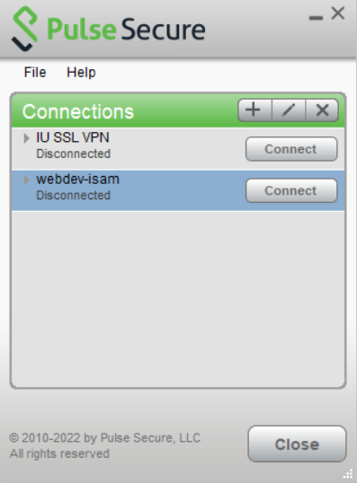

Once you’ve clicked the (+) it will ask for a name and a Server URL, the name can be anything you want. I put webdev-isam, and the Server URL is : <https://sslvpn.kean.edu/> and when you’re done with that step, all you have to do is press “Connect” and it will prompt you to add a Username and password, use your kean username and password and you will successfully login to the kean vpn.

There are two approaches developers can take when navigating through the large collection of legacy software files provided by Flarum. While Flarum has kept their library relatively clean for first time coders it may take time to adjust. One of the approaches to navigate through the coding files is through Linux.

* 1. **Linux Users:**

The following will be written for window user’s through the use of MobaXTerm which is a free X remote server that allows users to use ssh clients. Developers can download MobaXTerm on their machine using this link: [MobaXterm free Xserver and tabbed SSH client for Windows (mobatek.net)](https://mobaxterm.mobatek.net/) The screenshot below is what the developer should see once installed and open.

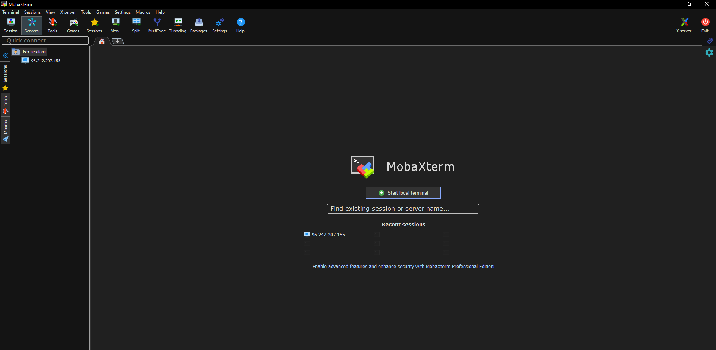

On the command line prompt developers are required to **ssh** into the Cougar Connect Flaurm code library. Developers and their basic Kean University assigned credentials are gathered from Kean’s Office for Computer Information Services. Developers will use their standard username credential as the username followed by the IP address that Cougar Connect is hosted on. The format of the Once the developers credentials are inserted they will then be asked for a password. This password is set to be the same for all developers: **\*\*\*\*\*\*\*\*\***.

Immediately after developers have access to the host they are able to navigate manually through the layers of coding folders using standard linux navigation commands. Developers can use ‘cd’ to change the directory they are viewing, and ‘ls’ to list the contents of the current folder. To access the main workspace for Cougar Connect developers will need

* 1. **Filezilla Users:**

FileZilla follows the central theme of open source tool usage for Cougar Connect. The link to download FileZilla is: [**FileZilla - The free FTP solution (filezilla-project.org)**](https://filezilla-project.org/)**.** Developers are **required** to download FileZilla in order to view and edit code files in Cougar Connect. There are two different types of FileZilla installations. FileZilla Client allows the transfer of files while FileZilla Server makes files available for others. The development team decided on downloading FileZilla Client for the development of Cougar Connect. Upon the complete installation of FileZilla Client developers should see the following screen:

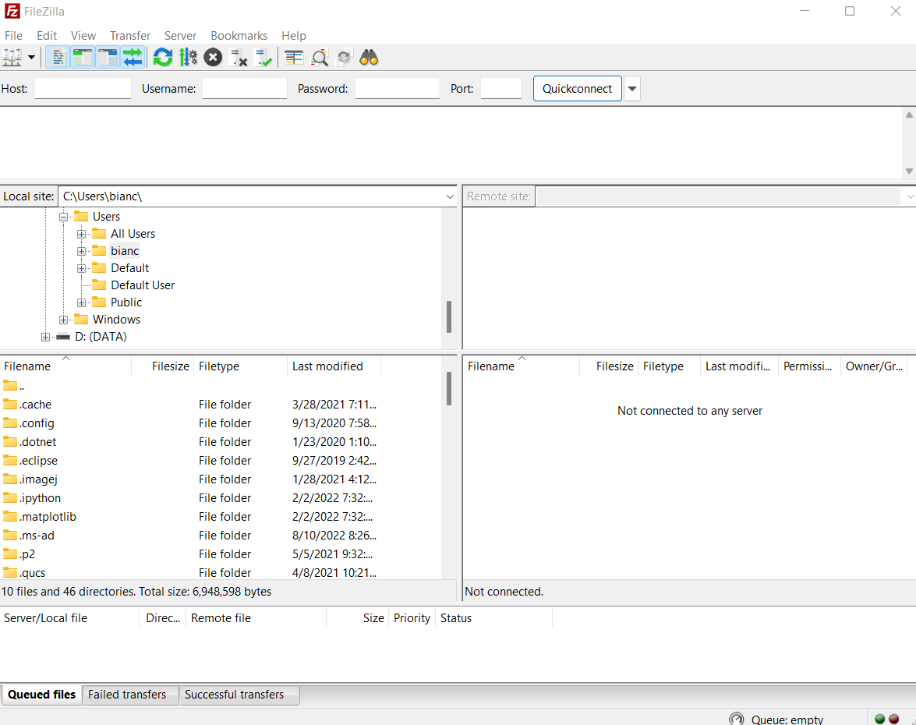

Similar to accessing Cougar Connect’s main workspace through Linux/SSh FileZilla requires a sign in that will only work once a developer is connected to the VPN in Pulse Secure. For developers signing in requires four fields: host, username, password and port.

The pathway to the main workspace is similar to Linux/SSH and is as follows:

*Note: Developers may need to alter permissions to read, write, and view files in the future thorough Linux. If this is the case permissions can be changed for entire folders in Linux through “chmod 777 [filename]”*

Below is what developers should see when done navigating to:

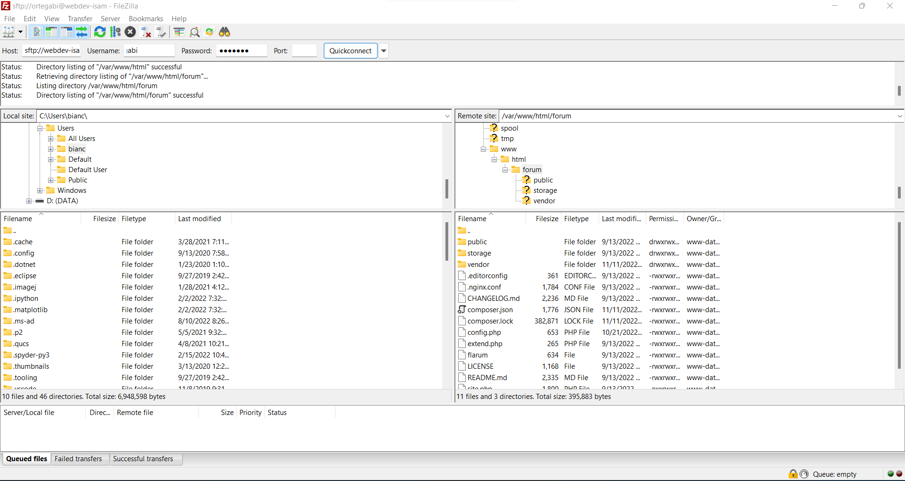

1. **Viewing and Implementing Code Changes:**

Filezilla offers users the ability to open files and make changes to their code. Users are able to open the file using different IDEs (Integrated Development Environment) and/or text editors such as Sublime Text. Since every group member has Visual Studio Code (IDE) installed onto their machines, we decided that we would be editing our files using this application. The following steps indicate how the users are able to open files using Visual Studio Code and editing changes onto the file.

1. You have to ensure that you are in the correct folder and are looking for the correct file. There will be two locations in which you can choose from in FileZilla. The left side contains all the files that are available to your local machine. The right side contains folders that are available remotely to all the group members of the project. To make changes to the correct file that pertains to CougarConnect, we will be working with the files on the right side.

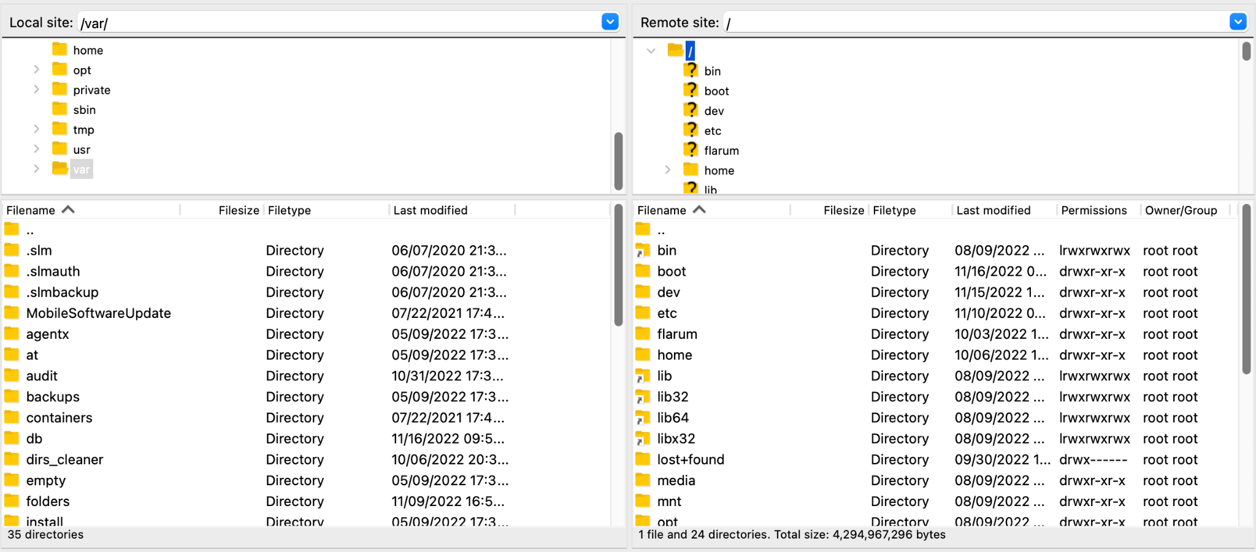

1. Once the correct file has been located, you will have to right click on that file (Control + Click on Mac). This will prompt you with a variety of options. You will proceed to click on **View/Edit** on the selected file.

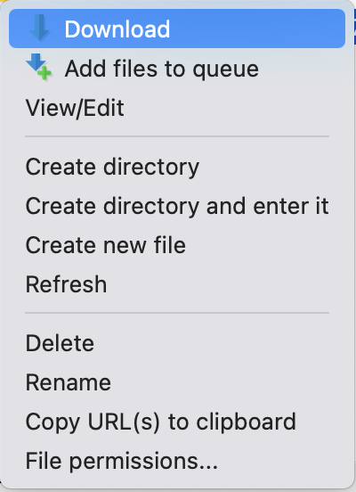

1. Once you have clicked on **View/Edit** it will ask you how you would like to open the file. Select on the option **Click Custom Editor** and then click on **Browse**.
2. When you are given the option to pick what custom editor to pick, look for Visual Studio Code under your applications. Once found, select that option.
3. The file will open using the Visual Studio Code IDE. Visual Studio Code allows the user to make changes and easily save them. In the example below the file **extend.php** is opened as an example on a Mac machine. 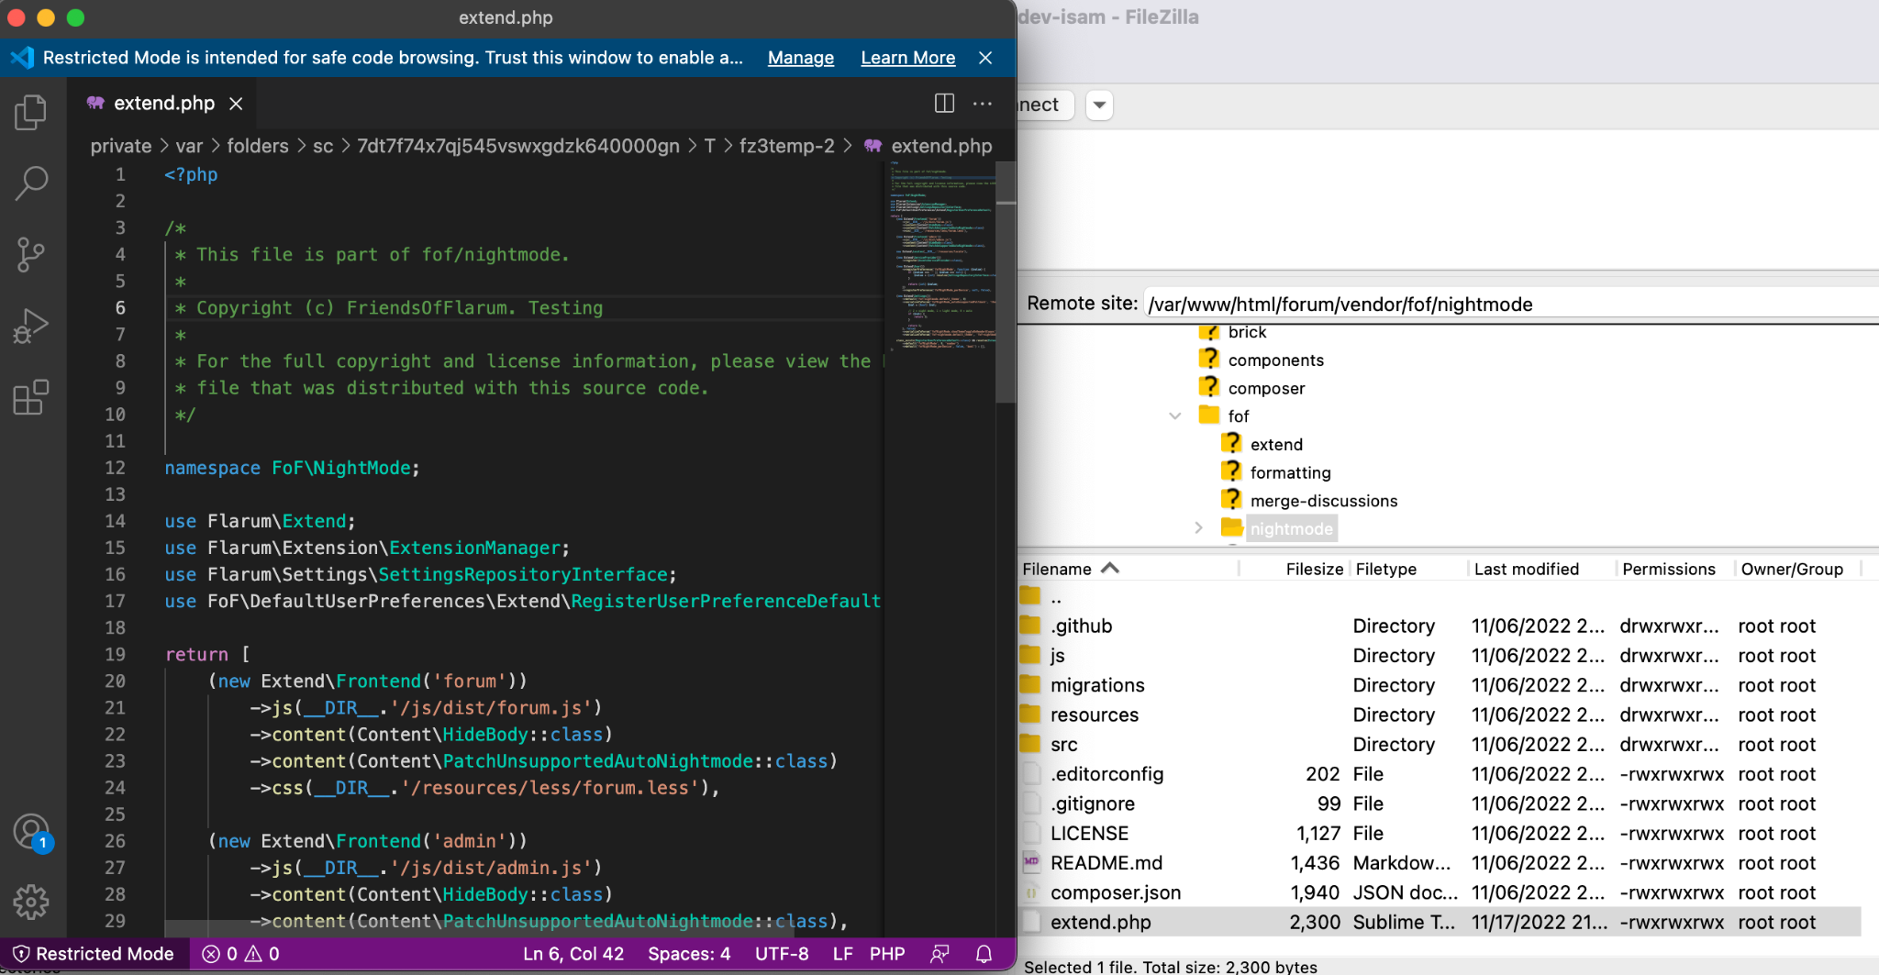

We decided to implement some changes onto the file. Once we had finalized all the edits within the file, we went and saved the file. When the file had been successfully saved, FileZilla prompted us to upload the file with the saved changes back to the server.

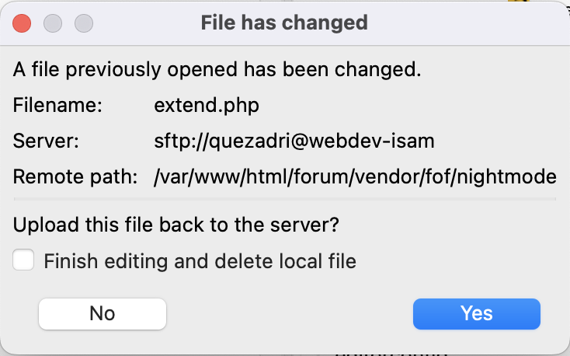

When the user selects to have the updated changes to be uploaded back to the server, the website will then display those given changes. The compatibility between FileZilla and Visual Studio Code renders us a simple and efficient way to commit changes to the website.

1. **Implementing Changes through Flarum Administration**
   1. **Adding External Packages/Extensions**

Flarum offers a variety of different extensions that are able to be added to the website. Some of these extensions that were added to Cougar Connect are Purify, GIFs, Mentions, FoF Night Mode, and Likes. These extensions allow the developers to implement more accessibility and fulfill the client’s user stories within the website. There are certain steps that must be taken to add extensions to the website. We will be providing the steps that are taken to add extensions to Cougar Connect.

1. To add extensions to Cougar Connect, you need to visit the following website: <https://freeflarum.com/extensions>. This website provides various packages that are able to be implemented and used as extensions. There are currently 175 different extensions that you are able to pick from.

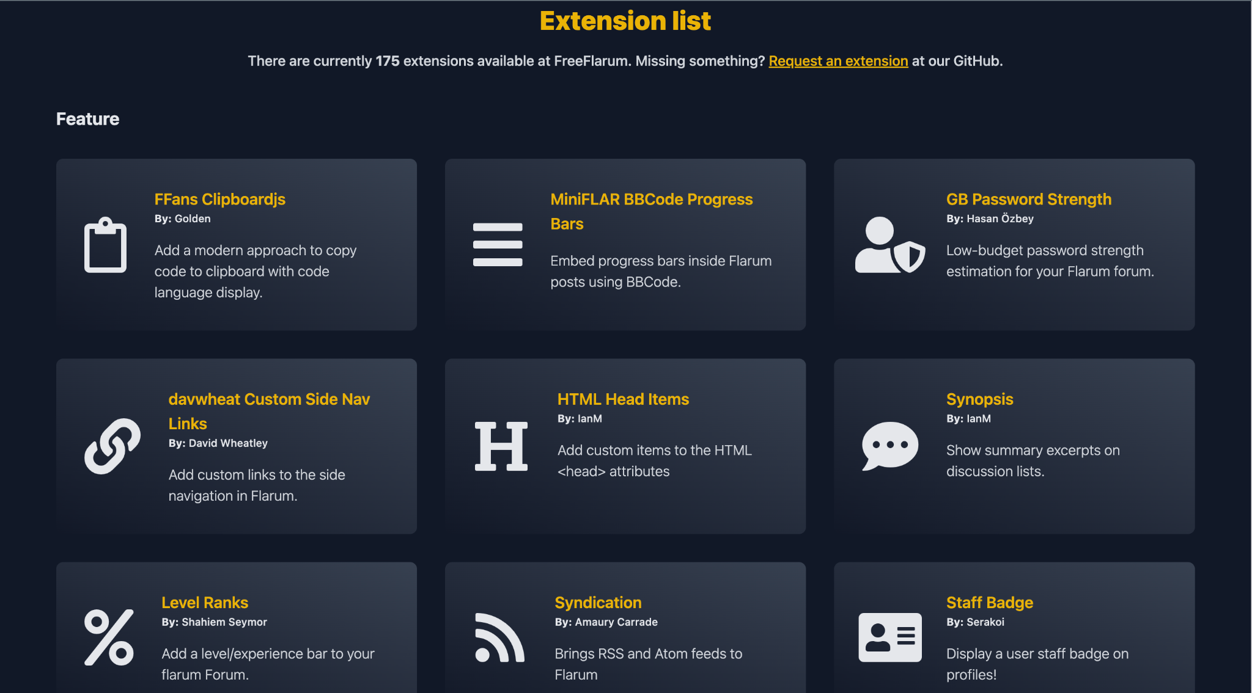

1. Once you have decided which extension you want to implement to the website, you will need to click on it. Once you have clicked on the package that you want, proceed to go to the bottom of the website. At the bottom of the website, look for the bold letters that state **Installation**. Copy the command that starts with **composer**. For this example, we will implement Flamoji to the Cougar Connect.

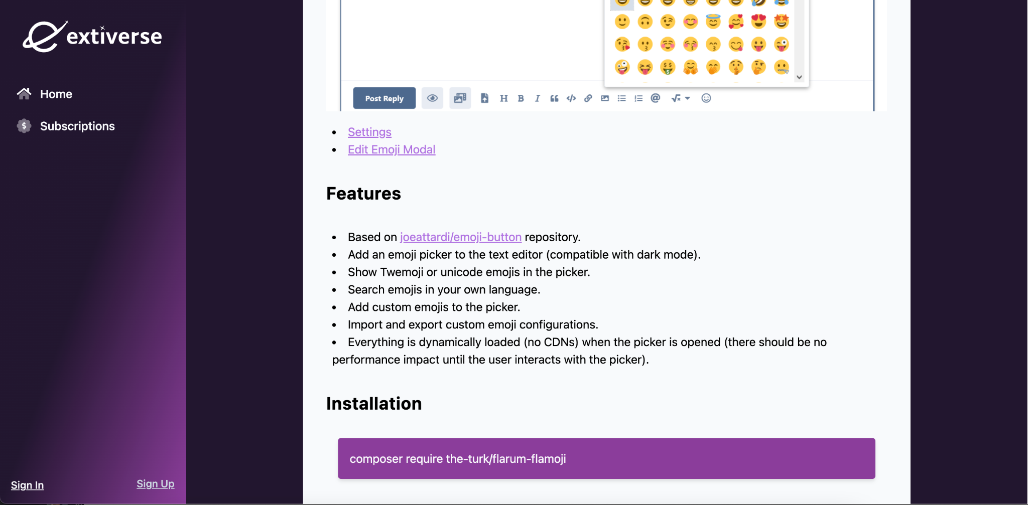

1. When the command has been copied, you will proceed to open up your Command Prompt on a Windows PC or Terminal on a Mac OS system. When in the Command Prompt/Terminal, you will need to log into the host server. In order to log into the host server, you need to enter your username followed by the host address. For this example, we logged into Ricardo Quezada’s administrative account.

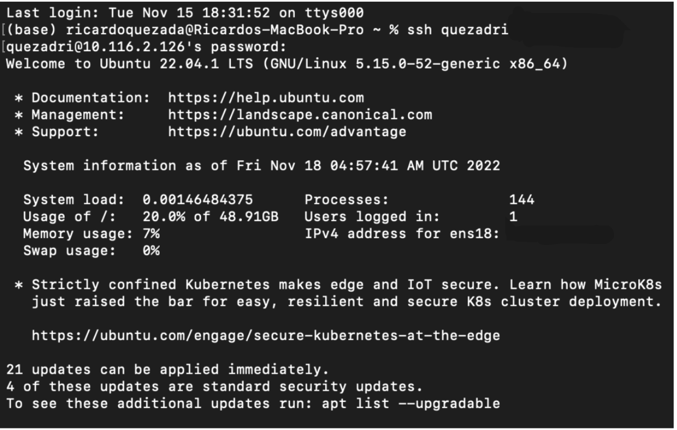

1. Once you have logged into the host server, you are now able to add the extension onto the website. The command that was copied in Step 2 will now need to be pasted into the Command Prompt/Terminal. Once that has been inputted, the installation should begin.

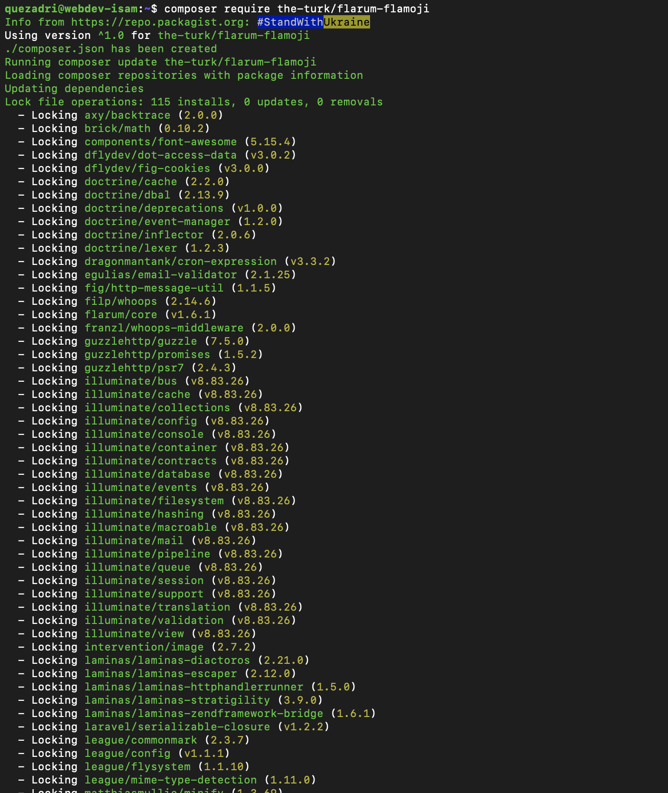

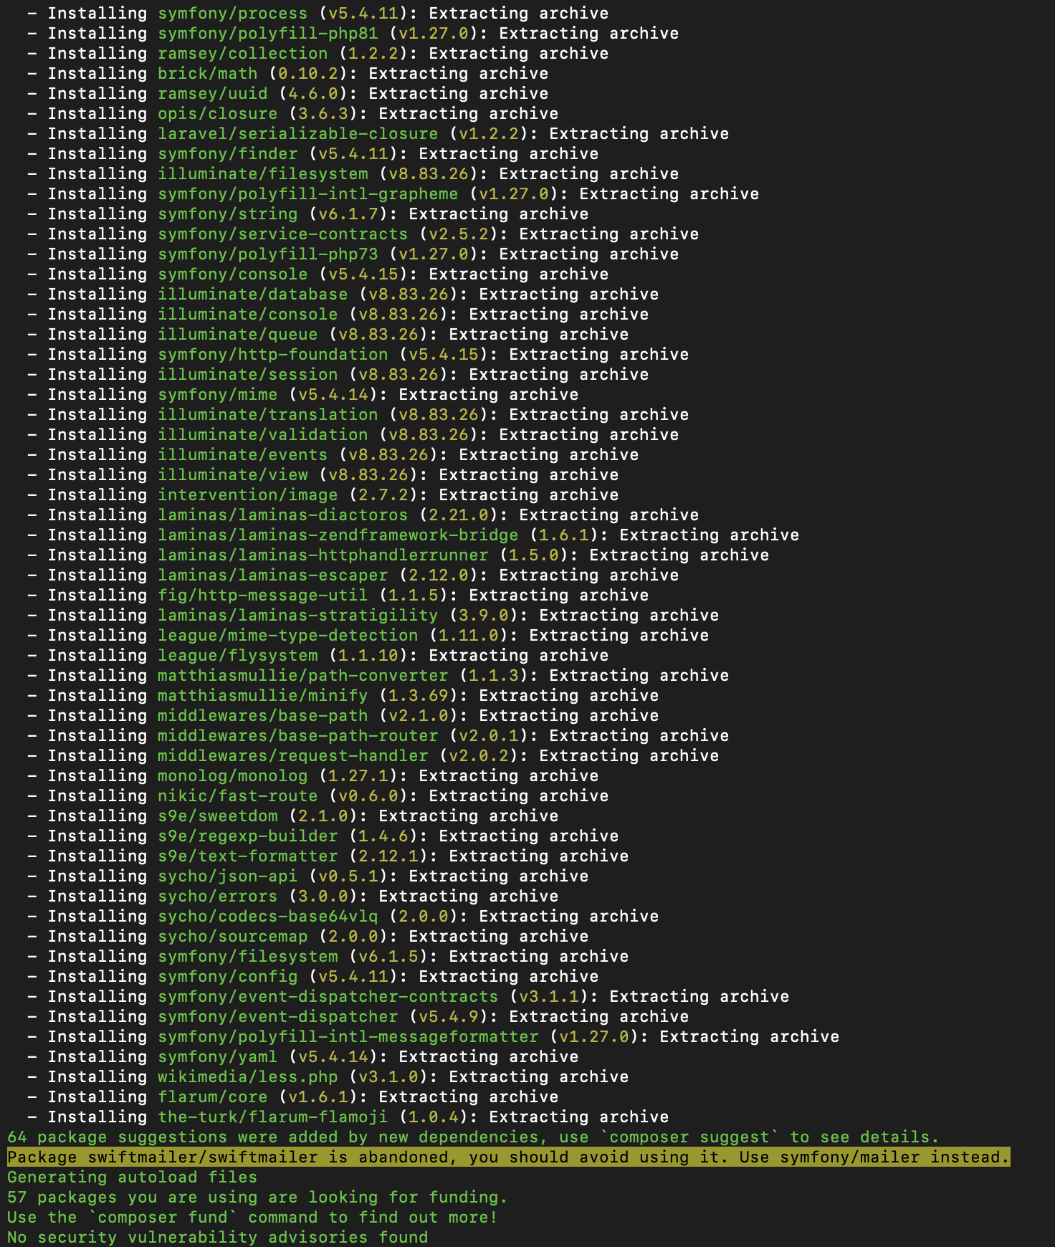

1. When the installation has finished, it should have synchronized with the FileZilla and be available on it. Now you are ready to view and make changes to the files that pertain to the Flamoji extension.

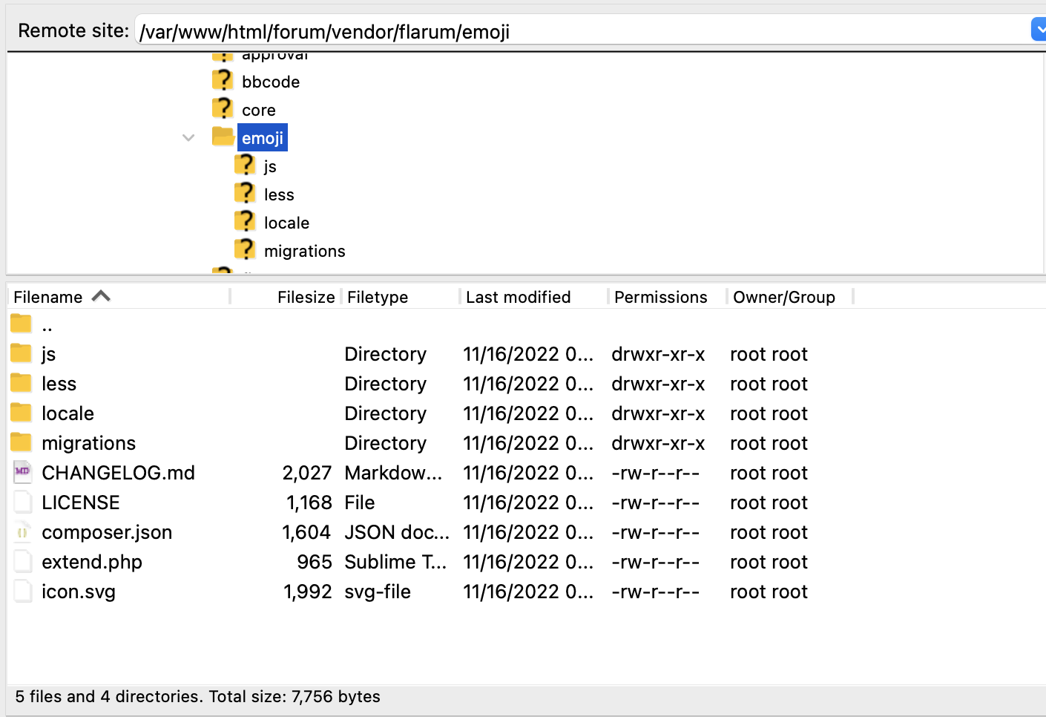

* 1. **Altering Existing Flarum Features**

Switching to Bianca Ortega’s administrative account as an example, other developers can alter and implement existing Flarum Features for more user accessibility. Below features that are already implemented in this version of Cougar Connect includes the ability to flag, import profile covers, and user “mentions”.

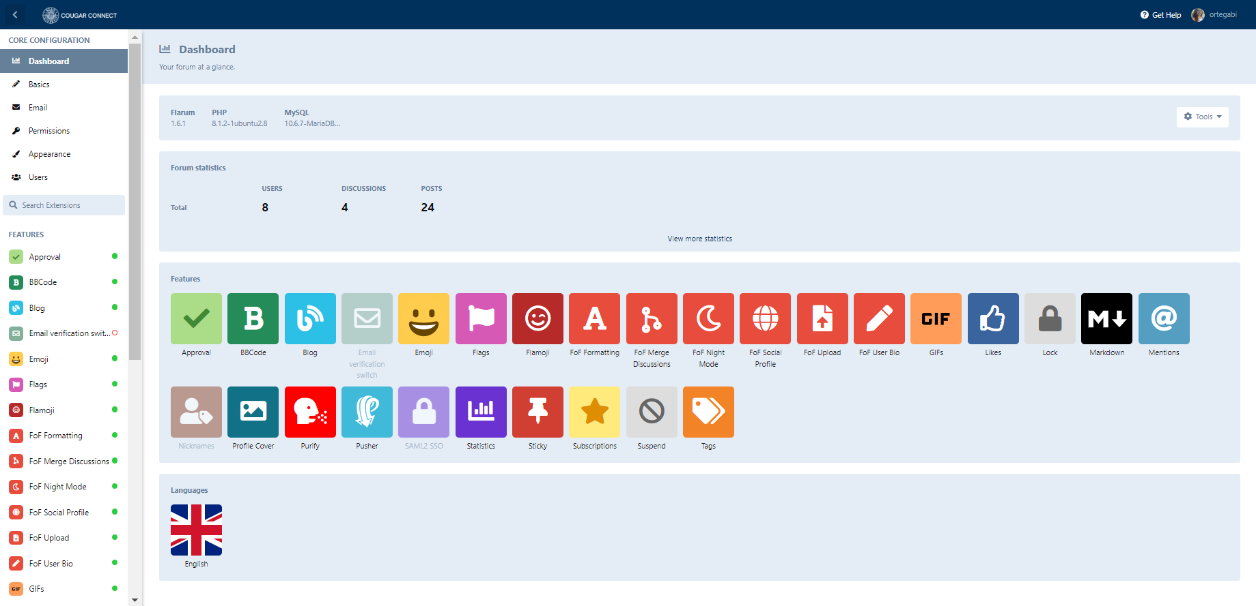

Developers can use the left hand menu labeled “Core Configuration” to change user permissions, view existing administrators and manually search for existing extensions. Those who prefer to work with more UI friendly controls but still desire to make changes to Cougar Connect can use these features and administration. Changes can be made with a simple switch to enable or disable the installed features/extensions.

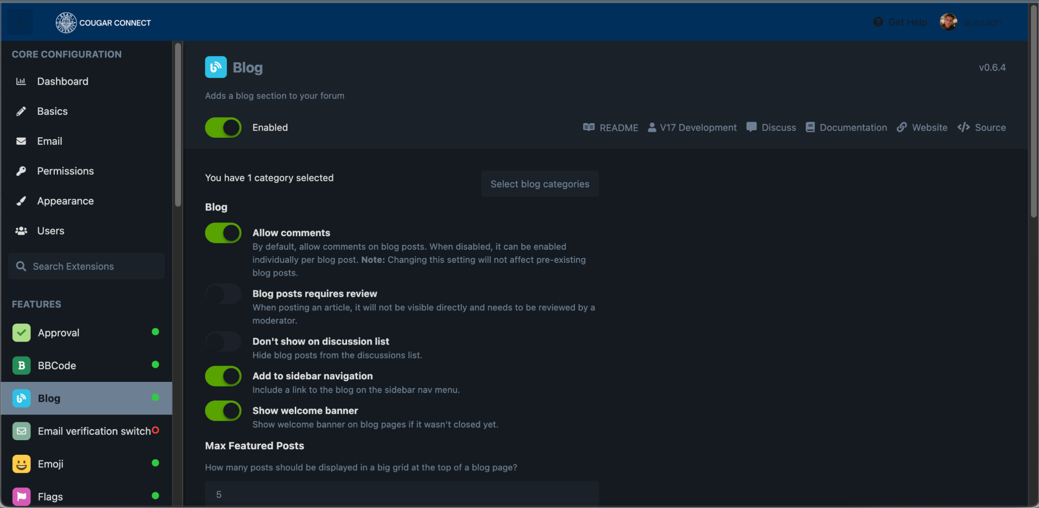

1. **Database to Server Connection:**

For this step we will be explaining how exactly the database is being used for our web server. For our Database we chose to work with MariaDB, and we can choose to either work on Terminal or with MySQL Workbench. We find it easier to work with Workbench so we would recommend you to work on Workbench. The first step should be how to connect to the database using MySQL Workbench (Before trying to access the database you should have your VPN on, the steps for this are above (Pulse Secure)):

1. You first install MySQL Workbench, then once that’s all done you need to create a connection to the database. The required inputs to connect to our database are the Connection Name, which you can give whatever name you want, the Connection Method which would be Standard TCP/IP over SSH, the Hostname which is webdev-isam or you can just put the ip address along with the port which is 22, your username for SSH and the password which you can store in vault, your MySQL Hostname which is localhost. You will also need your MySQL Server Port which is 3306, your username and your password. That’s all the required information you need to connect to the database.
   1.  - You click the (+) to add a connection to your MySQL Workbench
   2. 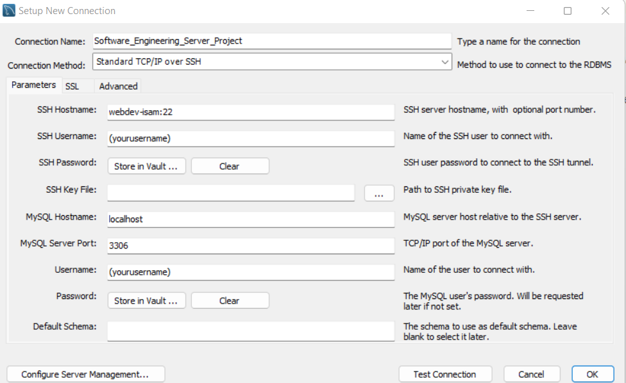- This is all the information you need to access
   3. 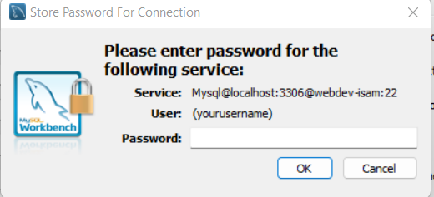 - This is what you get prompted when you put your password in a vault, just put your password and click “OK”.
   4. **PHP Connection to Cougar Connect Backend Example:**

Now that we’re done setting up the connection with our database, we will demonstrate how the data in the database is used on the web server (For this example we will be using another database and another web server to avoid making any mistakes on our project’s server and database and delaying our progress). Our front-end is written using HTML and the language we use to retrieve data from the database and put this data in the web page is PHP. That is the most important thing to take note of, if we didn’t have this language we would have to find another way or another language that’s able to retrieve data from both the back-end and the front-end and show the results in the front-end. We will be showing you just exactly how PHP is able to retrieve the data from both the backend and frontend and then echo it the frontend.

1. Getting the connection between PHP and the backend:
   1. 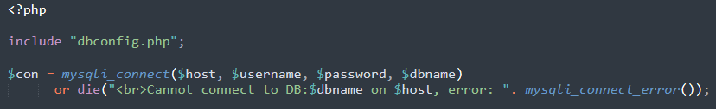- This is the code we use to get the connection to our database, where the $con stands for our connection variable and the mysqli_connect() is a built in function that allows us to connect to our database, as long as we provide the correct host, username, password and database name. We made another php file that contains the host, username, password and database for security reasons and the “include” function reads the variables that are in that php file. And below is the php file that contains all of the information:
   2. 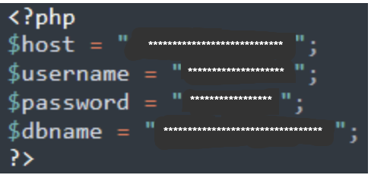 - This file is called “dbconfig.php”
2. Now the first thing we’re going to get is the login and password from our User, and the User inputs his login and password on our web page, which is written in HTML, so in order to retrieve what the User has put into the web page we use this function called $_POST[‘’]. Now we have the login and password the user has attempted to login with.
   1. 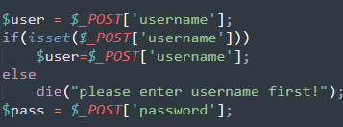 - We can also put some checking points to see if the User has attempted to put in a real username or just left it blank.
3. Now that we got the login and password the User has attempted to login with we can check if the Login and Passwords match the ones that we got in our database, since this is just an example we don’t actually have a table in our database for this. So we created one and this is how we created it:
   1. 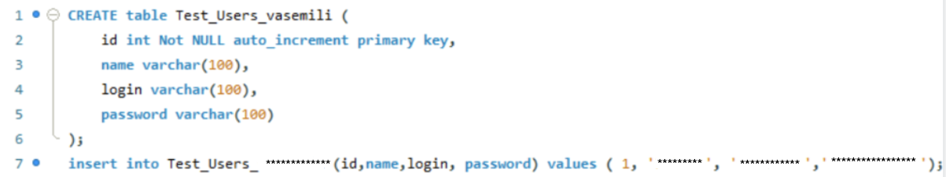
   2. And this is the table it creates: 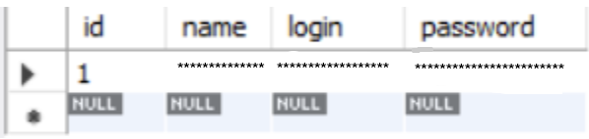
4. Now that we got our table, we can execute a SQL statement on PHP to get the information from this table depending on the specific Login given:
   1. 
5. We can then check if the User is in fact in our database (if login’s match) and if they do exist whether they entered the wrong password or correctly entered their password. If they enter the correct password and username, let them login and tell them they entered the right password, if they entered the wrong password don’t let them login and tell them they entered a correct username but the wrong password. This is the code to check for this:
   1. 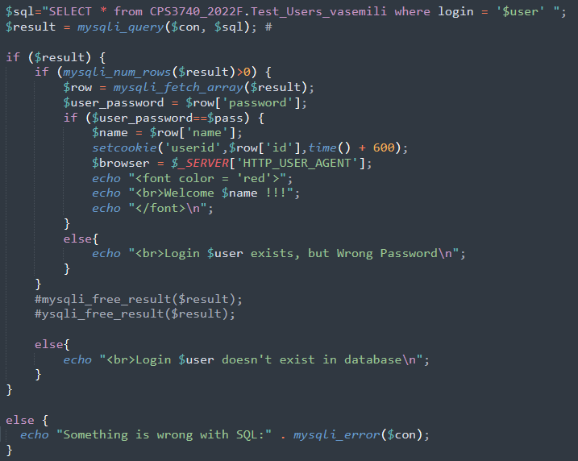
6. Once we’re done writing our code we can run the whole PHP file on our web server through filezilla:
   1. This is how the whole php file looks like: 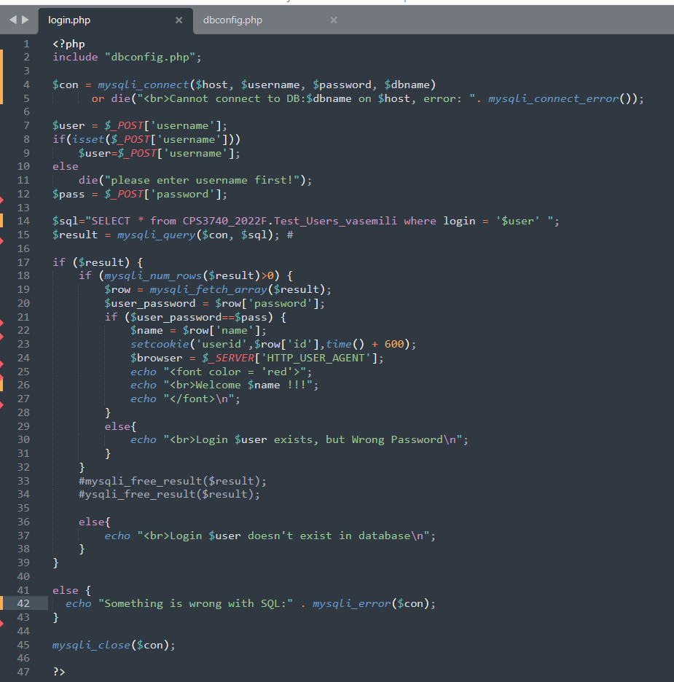
   2. There’s already an explanation of how filezilla works so we will just skip through the filezilla explanation and show you the transferring of files from my local drive to the web server: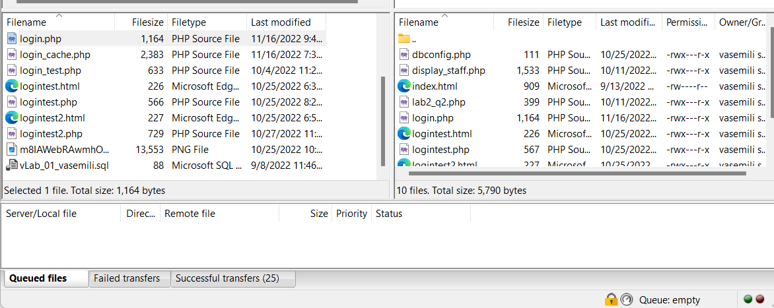
7. Now that our file has been executed by the web server, we can then check our web server to see if this is the case, remember that we only have 1 login and password at this time which is ‘******’ and *******!’, if the user doesn’t input the right username and password it should tell you so, and if you’ve inputted the correct username and password it should tell you “welcome $user !!!” in red.
   1. We attempted to login 3 times, once with the correct username and password, another time with the wrong password but the correct username and one last time with the wrong username and wrong password and these were the results respectively.
   2. 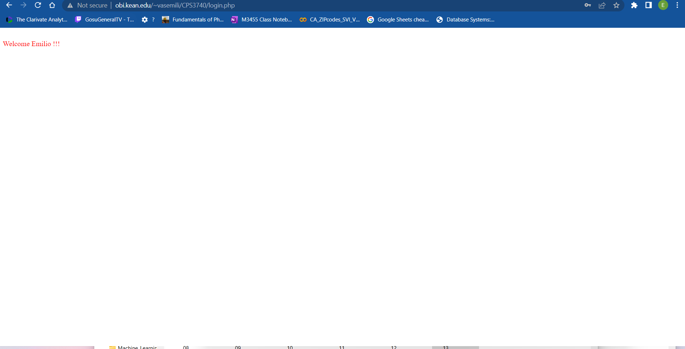
   3. 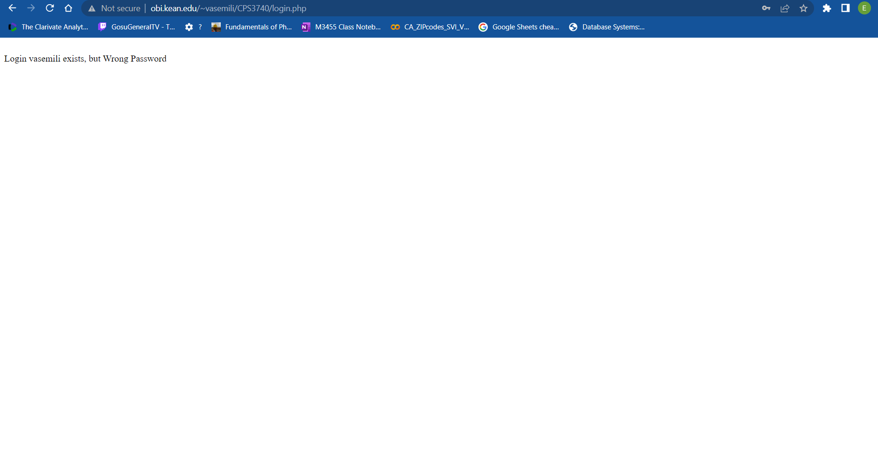
   4. 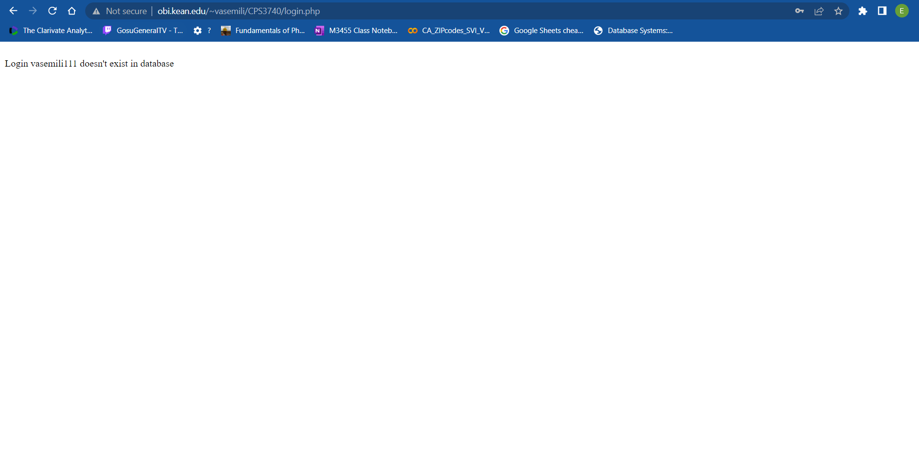

That is the end of the explanation of how the database and web page connect, PHP acts as a bridge between these two in order to connect them.